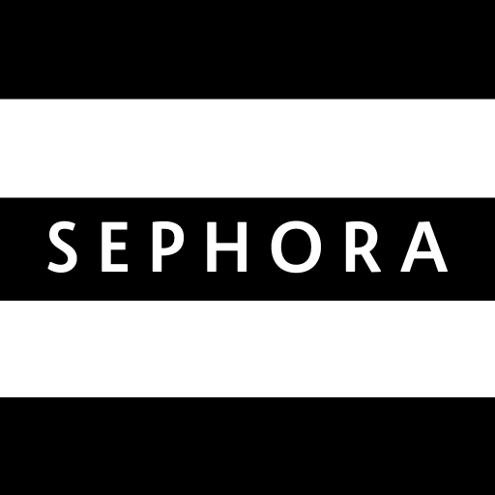**Executive Summary**

**[Team Member]**

**[Feiran Zhang, Xinyue Yu, Xiaoying (Shawn) Zou, Yufeng Xie, Zirui Zhou]**

**How can Sephora Compete with Other Cosmetic Selling Channels?**

**MKT 566**

According to the report published on March 10, 2022 from Statista (shown as the graph below), the revenue of the cosmetic market in the United States shows an increasing trend except for the COVID period. Cosmetics products have become more and more important in life and have become essential goods as they can provide a positive impact on people’s appearance and personality.

Graph 1. Revenue of the cosmetics market in the United States from 2013 to 2026(in million $)

This project focuses on Sephora, which is a leading cosmetic product collection store, by analyzing data including Sephora website reviews, Twitter posts, geographic data, and survey samples to see how can Sephora compete with other cosmetic selling channels including companies’ official websites, general e-commerce, drug stores, department store, and other cosmetic websites.

To better identify the market opportunity, the research focuses on different analyses including studying customer perception through sentiment analysis on Sephora website reviews and Twitter posts using JMP and Enginius, exploring Sephora’s positioning by doing factor analysis and drawing snake plots using JMP and Tableau, segmenting Sephora’s customers to four groups and extracting their traits by doing needs-based segmentation analysis using Enginius, and making predictions on purchase, satisfaction, recommendation, click rate, and transaction rate and developing logit targeting by doing predictive analysis using JMP. Based on all the results, we provide some recommendations and future improvements accordingly to help Sephora strengthen its market position.

# **Part 1 Define the Marketing Analytics Research Study**

Our main topic is to figure out how Sephora can keep or develop customers from other cosmetic selling channels. Since 2017, the web search volume of SKINCARE has continuously increased, suggesting the increasing consumer demand for skincare (Appendix 1.1). Compared to the booming industry, Sephora, the biggest skincare collection store in the world, shows a slightly deteriorating trend (Appendix 1.2) in web searches, indicating the probability of losing customers and opportunities. Because of the increasing demand of the whole industry and the possible loss of demand on Sephora, we infer that other cosmetic selling channels get more customers and fulfill more demand.

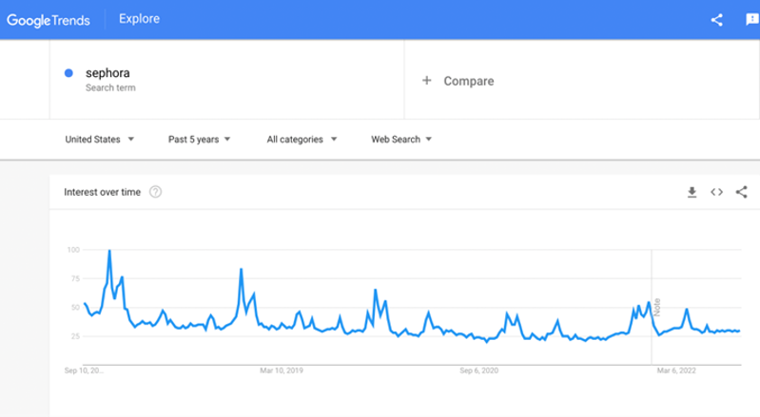 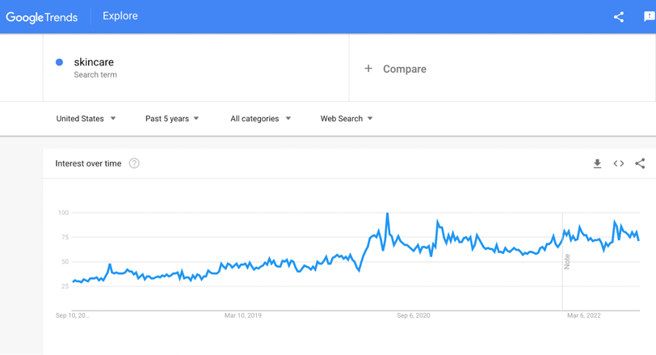

Graph 1.1 Decreasing interest trend of Sephora vs. Graph 1.2 Increasing interest trend of Skincare

**1.1 The Opportunity of Sephora**

* **The continuous growth of the whole cosmetics market**

Based on the prediction, the whole cosmetic market will exceed $716 billions by 2025 with an annual compounded growth rate of 4.75% worldwide. Sephora could get similar or even better growth during that period if it can launch a good strategy to keep and get more customers.

* **The booming of the E-commerce platform**

In recent years, e-commerce has played a greater role in the U.S. cosmetics industry. The share of online health and personal care sales as a percentage of total retail e-commerce sales was projected to increase from 7% in 2017 to 8.6% in 2024. It will be a good chance for Sephora to beat its competitor if it can utilize the e-commerce channel well.

* **The corporation with Kohl’s**

According to Sephora’s 2023 strategy, it will tie up the corporation with Kohl’s by opening 400 new stores at Kohl's shops. As its expansion, it is critical for Sephora to figure out the factors that can attract and retain customers from other cosmetic selling channels. Otherwise, tremendous expansion expenses and stagnant marketing volume might be a potential risk to Sephora.

**1.2 The Challenge of Sephora**

* **Quality Control Issue**

In 2017, a customer claimed that she tried on a shade of lipstick at a Los Angeles area Sephora and contracted herpes from the sample. A veteran Sephora brand's eye serum allegedly leads to a permanent burn. And in the past 5 years, similar accidents and news still appear from time to time.

* **Honesty Issue**

Sephora was claimed for fake employee reviews on its own brand product. An email from management to employees surfaced on Reddit in 2018 asking recipients to not only post glowing reviews of new products on Sephora's site but to also review other products as well to build a history for a trustworthy profile. They also detail instructions on how to avoid the reviews getting flagged for spam, clearly acknowledging wrongdoing.

Based on the findings above, we see a potential gap between the industry boom and Sephora’s limited performance. In a gesture to help Sephora to identify its marketing opportunity and devise robust marketing strategies accordingly, we conduct sentiment analysis, positioning and targeting analysis, needs-based segmentation analysis, and predictive analysis to better know about Sephora itself and its customers.

# **Part 2 Analyze Available Existing Data**

**2.1 Sentiment Analysis**

**2.1.1 Sephora Website Positive Reviews**

**Word Cloud**

* ‘Product’, ’skin’, and ‘makeup’ present the major products’ categories
* ‘Smells’, ‘feels’, and ‘dry’ are the most popular aspects that have been talked about

**Terms and Phrase (JMP Pro)**

* ‘Dry skin’, ‘oily skin’, and ‘sensitive skin’ suggest skin type is an important part to analyze
* ‘received this product’ suggests delivery service is an important aspect
* ‘felt like’ and ‘smells like’ suggests the user experience of skincare products and cosmetics is important

**Emotion Analysis**

* ‘Joy’ and ‘Trust’ are the most common feelings for customer shopping at Sephora
* ‘quality’ and ‘gorgeous’ shows the importance of the products’ quality and the importance of giving customers free samples of the product
* ‘everyday’ and ‘consist’ suggest a lot of customers would like to continue purchasing products from Sephora

**Topic Modelling**

Topic1: Skincare

Topic2: Shopping and User Experience

Topic3: Cosmetics

Topic4: Foundation

Topic5: Quality

**Summary**

From the positive review data on Sephora’s website, we can conclude that Sephora is attractive to Sephora because of the variable products, free samples and try-on, good product user experience, and so on. Also, Sephora’s products usually keep high quality.

**2.1.2 Sephora Website Negative Reviews**

**Terms and Phrase (JMP Pro)**

* ‘high hopes’ and ’want to like’ show that the high expectations of the customers sometimes are not satisfied
* ‘didn work’ and ‘waste of money’ show the effect of some products is don’t work as expected

**Emotion Analysis**

* ‘disgust’ and ‘anger’ are the most common feelings for customer shopping with negative ratings
* ‘disgust’ shows that the smell or the feeling of the products is not good and makes customers feel gross

**Topic Modeling**

Topic1: Hair

Topic2: Skincare

Topic3: Cosmetics

Topic4: Shopping Experience

Topic5: User experience

**Summary**

According to the negative reviews on Sephora’s website, we can conclude that Sephora also has some disadvantages, such as the purchase speed, some of the products are not cost-effective, and so on.

**2.1.3 Twitter Posts**

**Word Cloud**

* ‘Face’, ’beauty’, and ‘makeup’ present the major products’ categories;
* ‘Black’, ‘Friday’, and ‘sale’ show that promotion is one of the important and attractive things recently;

**Emotion Analysis**

* ‘joy’, ‘anger’, and ‘sadness’ are the most common feelings for customer shopping at Sephora;
* The distribution of different emotions in Sephora-related posts on Twitter is more even.

**Topic Modeling**

Topic1: Shopping Experience

Topic2: Promotion (Black Friday)

Topic3: User Experience

**Summary**

From the reviews and posts from Twitter that are related to Sephora, we can see one of the best methods for Sephora to attract more customers on social media is promotion. In general, Sephora has a good reputation on social media.

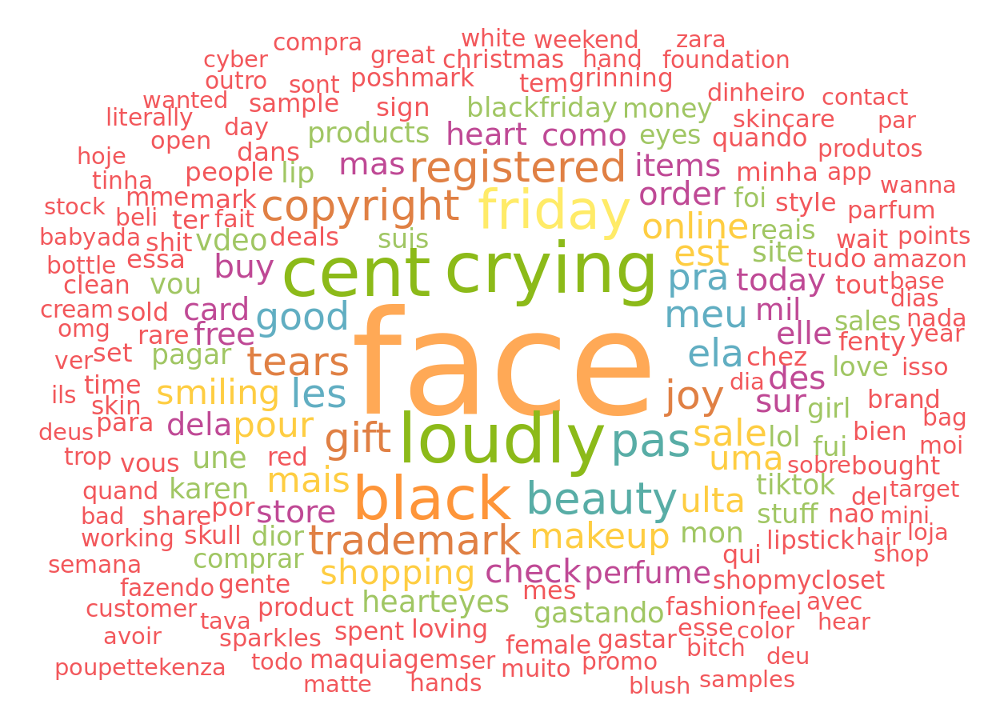

Graph 2.1 Words clouds of Twitter posts

**2.2 Geotargeting Analysis**

We choose 3 different Sephora stores based on the location distribution plot as analysis examples. By conducting geotargeting analysis, we want to come up with some suggestions for Sephora separately based on the difference between the demographic data of different areas.

**(1) Northeastern of the United States - New York - 10007**

**Major segments:** 99.34% Laptops and Lattes + 0.66% Metro Renters

|  |  |  |  |
| --- | --- | --- | --- |
| **Households** | **Average Household Size** | **Median Age** | **Median Household Income** |
| 1,307,500 | 1.87 | 37.4 | $112,200 |

**Recommendation:**

* Emphasize the environmentally friendly characteristics of the products
* Consider promoting the products targeting on using in office environments

**(2) Central of the United States - Minneapolis - 55431**

**Major segments:** 26.21% Comfortable Empty Nesters + 17.91% In Style + 17.36% Parks and Rec

|  |  |  |  |
| --- | --- | --- | --- |
| **Households** | **Average Household Size** | **Median Age** | **Median Household Income** |
| 3,024,200 | 2.52 | 48 | $75,000 |

**Recommendation:**

* Marketing can focus on White people
* For advertisement or other marketing strategies, could invest more on traditional channels such as radio or TV, not the Internet
* Emphasize that the products of Sephora are healthy and safe because elder people care about health more

**(3) Northwestern of the United States - Los Angeles - 90017**

**Major segments:** 41.73% Trendsetters + 22.83% NeWest Residents + 15.59% High Rise Renters

|  |  |  |  |
| --- | --- | --- | --- |
| **Households** | **Average Household Size** | **Median Age** | **Median Household Income** |
| 1,319,400 | 2.12 | 36.3 | $63,100 |

**Recommendation:**

* Provide more skincare products for 30s customers
* Provide the latest and branded products
* Site new stores around public transportation stations as lots of Trendsetters are taking public transportation

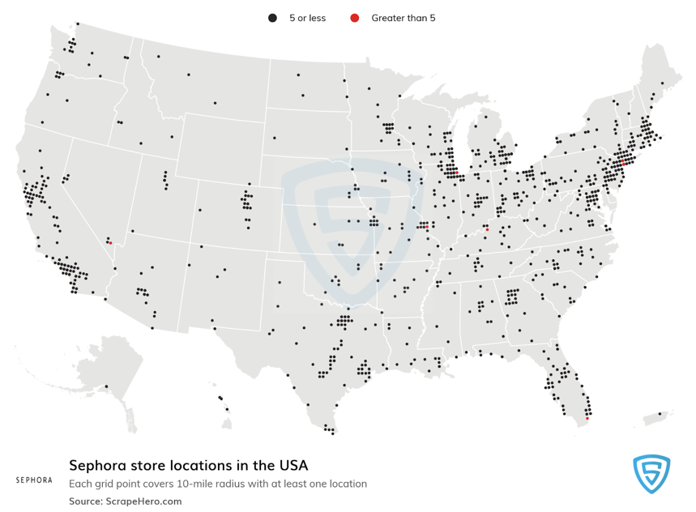

Graph2.2 Location of Sephora offline stores in USA

# **Part 3 Collect and Analyze Survey Data**

**3.1 Positioning of Sephora and its Competitors**

Sephora is positioned as a leading cosmetic products collection store expert in cosmetics and perfumes. Sephora bridges the gap between a drugstore and a high-end department store. It enables customers to casually browse without being harassed by consultants in department stores, and it has more luxurious settings and various products than drugstores.

**3.1.1 Sephora Positioning Statement**

* **For** cosmetic customers
* **Who** have the pursuit of beauty and want quality and extreme purchase experience.
* **Sephora** is a leading cosmetic product collection store
* **That** offers an assortment of prestige products in every category, unbiased service from beauty experts and an interactive shopping environment
* **Because** Sephora is owned by LVMH, the world’s leading luxury goods group and provides an increasing assortment of products from carefully curated brands, featuring emerging favorites, trusted classics, and Sephora’s own line, Sephora Collection

**3.1.2 Advantages and Disadvantages**

**Advantages**

According to the snake plot (Appendix 3.1) and perceptual map (Appendix 3.2, 3.3, 3.4), Sephora has several advantages compared to other channels.

* Sephora has the highest availability of samples and try-on. This is one of the advantages that Sephora has. After buying cosmetic products, Sephora provides some free samples, which may include fragrance, skincare, and/or makeup items. The high availability of samples improves the shopping experience and incentivizes future purchases if customers try the samples and would like to buy the full size.
* Sephora has the highest score for convenience and the second-highest score for speed of purchase. Customers can not only easily compare different options, but also easily and conveniently place orders.
* Another advantage that Sephora has is the quality of its products. The score of the quality of products is almost the same as the company’s official website. Customers can trust Sephora and can worry less about whether the product is fake or not, or it is broken or not.
* Sephora also has an advantage in return policies. Customers can return any product for no reason easily not only for online shopping but also for in-store shopping. Customers can also return the products even without a receipt, as long as the purchase record is in the Sephora system, in case customers might lose their receipts.
* Sephora has the highest score for a variety of products. Sephora is a powerful beauty presence providing one-stop shopping that includes a variety of brands and products. Customers can purchase all kinds of cosmetic products from different brands in one single order which can easily satisfy customers’ demands.

**Disadvantages**

Sephora is generally getting a higher score in different attributes, but there are still several aspects that it can improve.

* Sephora has a lower score on price, which indicates that customers think Sephora is more expensive than general e-commerce channels, drug stores and other beauty websites. If Sephora can’t provide more extreme experiences than these channels, it would probably lose some customers and hard to attract new customers.
* Sephora has a lower score on the availability of products than the company’s official website, suggesting Sephora is more likely to sell out than the company’s official websites, especially in promotion events.
* Sephora has a lower score on the speed of purchase compared to general e-commerce channels. General e-commerce has an easier purchase process and customers are more familiar with those general e-commerce channels which enables them to shop for what they want in a short time. Besides, for offline Sephora, customers might sometime be unable to find a free associate to assist their shopping or cannot find what they want quickly in-store, which will increase the shopping time and lower the speed.

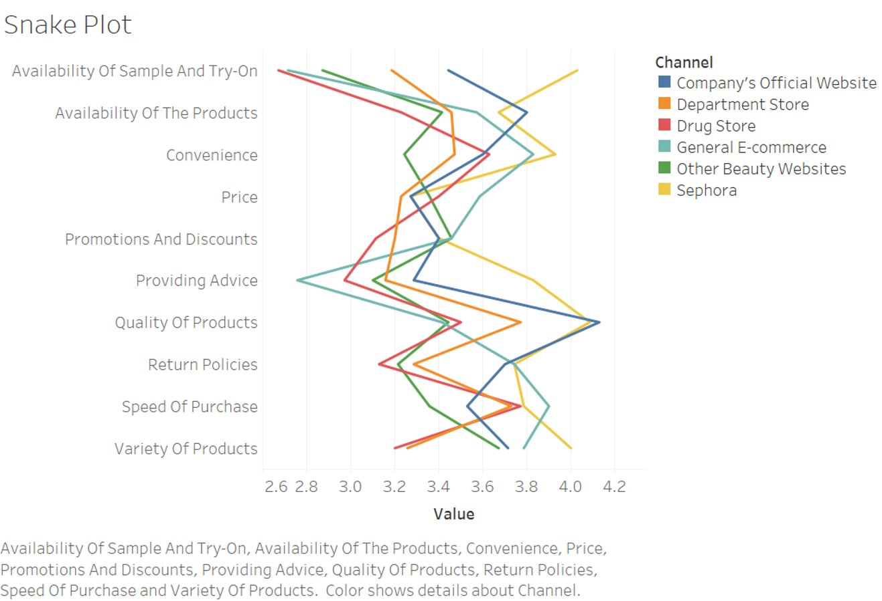

Graph 3.1 The snake plot of positioning

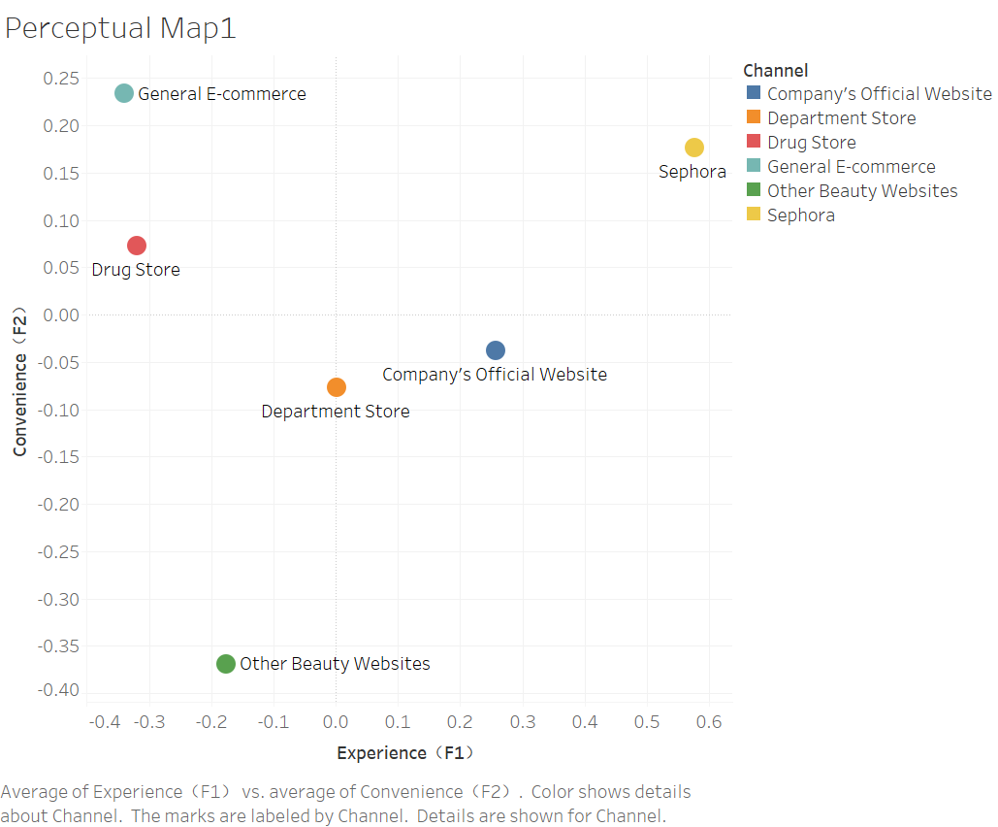 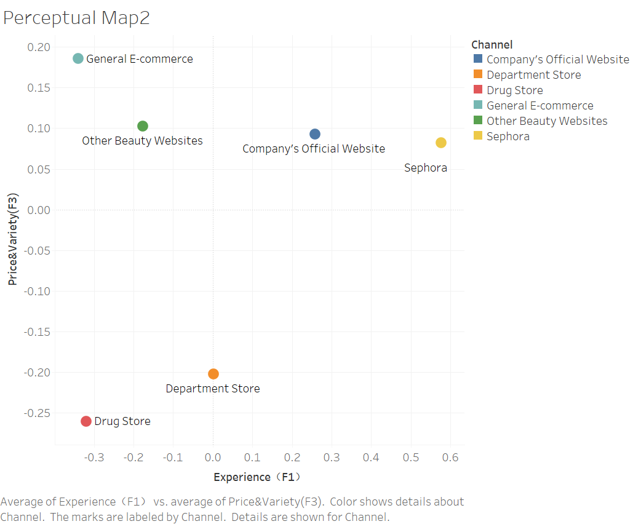 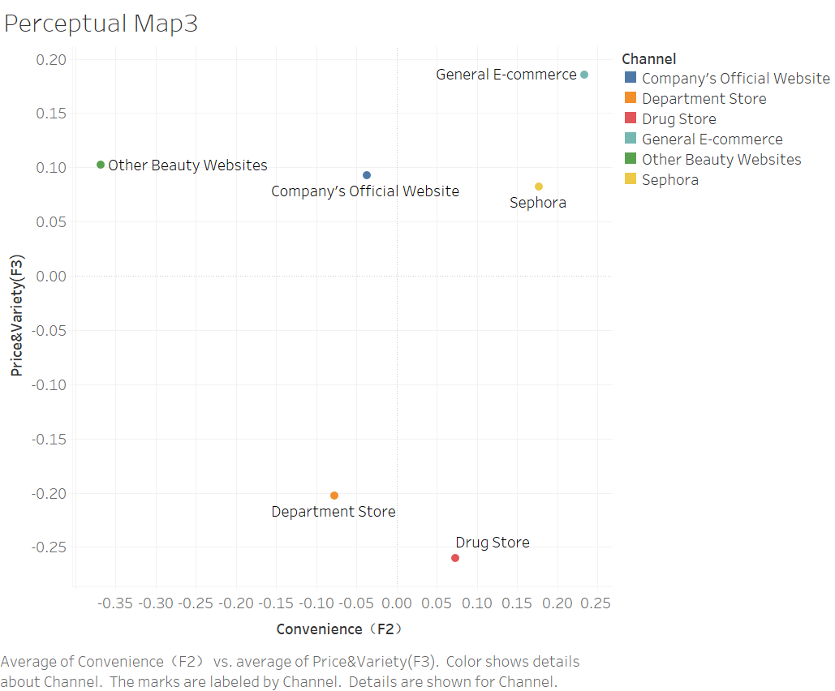

F1 vs F2 F1 vs F3 F2 vs F3

Graph 3.2 Perceptual maps

**3.2 Deep study of the customers of Sephora – Segmentation Analysis**

**3.2.1 Data**

Data collected through the survey is divided into two parts for needed-based segmentation: Segmentation Variables and Descriptor Variables. Segmentation variables come with the rank of the order (scale: 1-10) for each need customers potentially require through Sephora’s shopping experience as shown in the table(Appendix 3.6). Then, the rank for each variable is converted into the importance rate by simply transposition. The smaller the rank number is, the higher the rate will be, hence the more important customer thinks of the variable.

Descriptor Variables are comprised of behavioral data and demographic data, both of which are collected for discriminant analysis purposes. The table (Appendix 3.7) illustrates the questions for each variable. Most of them are rated on a scale from one to five.

**3.2.2 Clustering Comparison**

To better explore the optimal segmentation solutions, both Hierarchical clustering and K-means clustering are carried out without manually defining the number of segments initially. The table(Appendix 3.8) summarized the comparison of each method’s performance in terms of statistical significance as well as managerial usefulness. In conclusion, K-means clustering is adopted for further segmentation analysis for its relatively better performances in both dimensions.

**3.2.3 Segmentation Analysis**

K-means clustering generates 4 Segments as shown in the table (Appendix 3.9). Notice that the Variety of products is removed because of high collinearity with variables present in the report. Scree Plot(Appendix 3.10) suggests that the elbow is created when the number of centroids is 4, entailing a 2200-sum squared error for the clustering model. The Confusion Matrix (Appendix 3.11) illustrates the accuracy of the clustering is 91%, and the predicted segments are distinguishable enough to differentiate most of the customers. Overall K-means model is statistically significant.

The table (Appendix 3.12) illustrates the traits for each segment. In the concept of needs-based segmentation, these variables demonstrate the attitudinal needs customers expect from skincare and cosmetics products.

**Segment 1** has a statistically stronger emphasis on Convenience and Speed of Purchase, which is generally convenience related, while weaker emphasis on Return Policy, Providing advice and Sample and try-on, all of which are services related. Customers in Segment 1 concern more about if they can get the products easily and fast than how well the interactions with sellers are. Thus, we name the segment 1 **Convenience Seekers**

**Segment 2** cares more about Providing advice, Price Promotions & Discounts, and cares less about the Quality of the products. Customers in this section seek good deals with direct advice. They are not a big fan of quality or ingredients but the ban on promotions. Thus, we name the segment 2 Value for **Service Seekers**

**Segment 3** concerns a lot about the quality of products as well as Price while doesn’t concern Convenience or Speed of Purchase. In some ways, customers in this segment are quite different from that in Segment 1. They are more careful about the quality and the price even if sometimes it is not easy and quick to get good products they like. Thus, we name the Segment 3 Value for **Quality Seekers**

**Segment 4** focuses more on the Return Policy, Providing advice and Sample and try-on while doesn’t care too much about Price, Convenience and Promotions &discounts. It is nearly the opposite of Segment 1. Customers in this segment put emphasis on the services and experiences of their purchase even if it sometimes costs more. Thus, we name it **Service Seekers**.

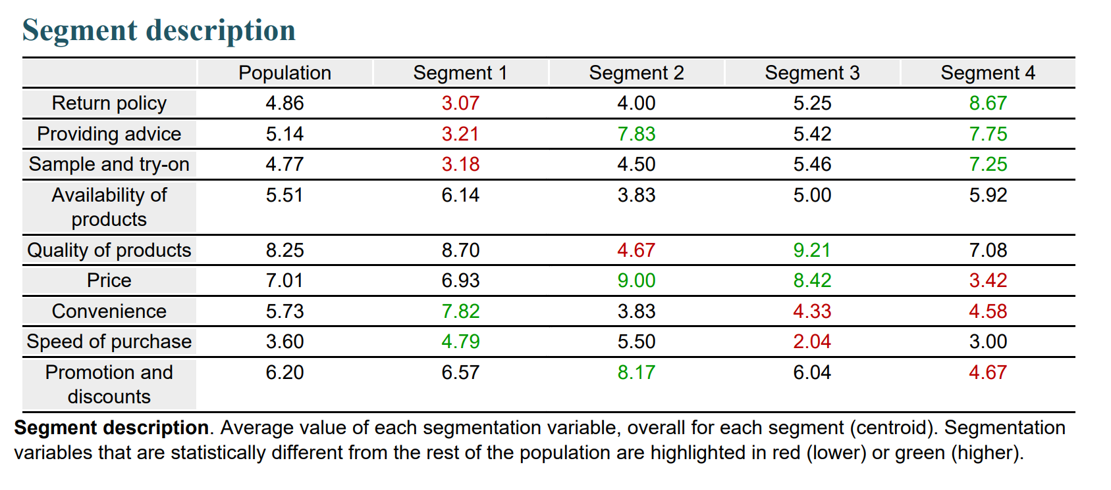

Table 3.1 The segment description

**3.2.4 Segment Persona**

The table (Appendix 3.14) illustrates the behavioral and demographic attributes of each segment we just defined. Notice that there are just a few descriptor variables are statistically significant, suggesting strong homogeneity among our survey takers. Future work can also pay more attention to diversifying survey takers.

Segment 1 prefers to shop for single cosmetics products rather than set. Segment 2 prefers to reference a friend’s opinion. Segment 3 has a relatively low education level and believes in the brand reputation when purchasing cosmetics. Segment 4 doesn’t care about the brand and always knows what they want to purchase.

Combined with the segmentation analysis above, the persona for each would be the following:

**Segment 1:**

Customers who like fast and easy shopping. They don’t necessarily need services when making purchases, and they might frequently shop for single items especially some essential skincare supplies each time rather than a set or combination.

**Segment 2:**

Customers who shop for skincare and products economically. They don’t care too much about the quality of products and often seeking for professional advice as well as friends’ recommendations when making the purchase. They believe price and promotions are strong driving factors when shopping for these products.

**Segment 3:**

Customers who seek quality goods at reasonable prices. They have relatively lower education levels and prefer to rely on a good brand image when making purchases. They don’t rush making decisions which mean sometimes they could bear long wait and tedious shopping processes in order to get the quality deal they want.

**Segment 4:**

Customers who have a strong understanding of what their needs are and do not believe in the brand image as the decisive factor to consider purchasing skincare or cosmetic products. They expect a good experience and services from product shopping such as professional advice, samples and try-on and a good return policy.

**3.3 Predictive Analysis**

**3.3.1 Purchase**

**Model:** The p-value of Chi Square=0.0086<0.05, so the model is significant. The R-Square is 21.53%, suggesting the model is not good enough. Not all parameters are significant, among them Gender and Age are significant. The model can capture 92.3% of customers who will purchase but can only predict 44.4% of customers who will not purchase rightly.

**Equation:** Ln(odds) = 0.9815 - 0.4213*Monthly Expense + 1.4786*Gender - 0.8654*Age + 0.4342*Try by Myself - 0.4043*Cosmetic Set + 0.5068*Emotional

**Interpretation:** A younger female who is more emotional, has fewer monthly expenses, prefers to try the product by herself, and less likes cosmetic sets is more likely to purchase in Sephora.

**Logit targeting:** Logit targeting has a lift in capturing customers than random targeting. The biggest lift, which is 15%, happens when 60% of the market is advertised.

**3.3.2 Satisfaction**

**Model:** The p-value of F Ratio=0.0522>0.05, so the model is slightly not significant. But the p-value is still less than 0.1, suggesting a fine significance. The R-Square is 23.34%, suggesting the model is not good enough. Not all parameters are significant, among them Service and Monthly Expenses are significant.

**Equation:** Satisfaction = 5.6636 - 0.1337*Ingredients - 0.2232*Service + 0.1637*Same Brand + 0.1791*Try by Myself - 0.2335*Monthly Expenses - 0.2829*Education

**Interpretation:** A customer who pays less attention to the ingredients, pays less attention to the service, prefers to buy products from the same brand, prefers to try by themselves, has fewer monthly expenses, and has a lower education level has a higher satisfaction level.

**3.3.3 Recommendation**

**Model:** The p-value of F Ratio<0.0001<0.05, so the model is significant. And the R-Square is 49.56%, suggesting the model is somewhat good. Not all parameters are significant, among them Appearance and Age are significant.

**Equation:** Recommendation = -1.1393 + 0.8822*Appearance + 0.4719*Price Conscious + 0.3376*Same Brand + 1.0783*In Store + 0.6055*Age

**Interpretation:** A customer who is more mature, pays more attention to appearance, is more price sensitive, prefers to buy products from the same brand, and prefers to buy products in-store tends to be more willing to recommend Sephora to others.

**3.3.4 Click Rate**

**Definition:** (Times of going to Sephora stores or using Sephora website/App in the past year)/(Times of being advertised by Sephora in the past year)

**Model:** The p-value of F Ratio=0.0009<0.05, so the model is significant. And the R-Square is 39.20%, suggesting the model is not good enough. Not all parameters are significant, among them Service, For Myself, Emotional, Gender, and Education are significant.

**Equation:** Click Rate = 5.0069 - 0.1726*Ingredients + 0.2622* Purchase Convenience - 0.2890*Service - 0.4200*For Myself - 0.3459*Emotional + 1.0161*Gender - 0.7968*Education

**Interpretation:** A female who is less emotional, pays less attention to ingredients, pays more attention to purchase convenience, pays less attention to service, prefers to buy for herself, and has a lower education level tends to show a higher Click Rate when she is exposed to advertising.

**3.3.5 Transaction rate**

**Definition:** (Times of purchasing in Sephora)/(Times of going to Sephora stores or using Sephora website/App in the past year)

**Model:** The p-value of F Ratio<0.0001<0.05, so the model is significant. And the R-Square is 53.67%, suggesting the model is somewhat good. Not all parameters are significant, among them CTR, In-Store, and Friends’ Opinions are significant.

**Equation:** Transaction Rate = 0.6341 - 0.2362*Click Rate - 0.2917*In-Store + 0.1145*Mature + 0.0785*Brands - 0.0816*Indecisive + 0.1424*Friends’ Opinion - 0.0828*Cosmetic Set

**Interpretation:** A person who is more decisive in purchasing, has a lower click rate, prefers to purchase the products online, pays more attention to the brands, pays more attention to friends’ opinions, and less likes cosmetic sets tends to show a higher transaction rate. People who show a lower click rate tend to have specific demand for products so that they are more likely to purchase while people who show higher a click rate may just go through the webpage or store but are unwilling to purchase.

**3.3.6 Segments Performance**

Segment 2 is the most valuable segment with the highest satisfaction, recommendation tendency, and transaction rate, while segment 4 has the highest click rate.

|  |  |  |  |  |
| --- | --- | --- | --- | --- |
| Average | Satisfaction | Recommendation | CR | TR |
| Segment 1 | 3.0357 | 5.9286 | 106.31% | 59.79% |
| Segment 2 | 4.5000 | 7.8333 | 132.80% | 78.96% |
| Segment 3 | 2.4583 | 4.7500 | 143.74% | 52.94% |
| Segment 4 | 3.5833 | 5.8333 | 179.60% | 51.36% |

Table 3.1 Segment Performance

# **​​Part 4. Develop Recommendations Based on the Results of the Data Analytics**

**4.1 Positioning**

**(1) Recommendation for experience**

Sephora should provide a more extreme experience compared to other channels. For example, Sephora can try to provide skin type tests both online and offline to help customers better choose the skincare products that are suitable for their skin type. Sephora can also provide skin and lips color tests and shape tests to help customers find what suits their skin tone, lips color, face shape and other features. Sephora should provide a more professional platform for cosmetic products to attract customers to shop at Sephora even though the price would be a little bit higher than other channels.

**(2) Recommendation for inventory management**

Sephora should optimize its inventory management strategy. For example, Sephora can do some trend and product analysis to predict which item would have a higher demand in the future. Besides, Sephora should increase the inventory level for products that would have some promotions and discounts recently to incentivize customers to shop. What’s more, Sephora should improve its distribution strategy and be able to transfer inventory between different warehouses quickly to increase flexibility.

**(3) Recommendation for speed of shopping**

For offline Sephora, Sephora can install an iPad at every section throughout the store to enable customers to quickly search between different products and different colors, read the reviews and prices on different products, and show trends and new products to reduce the time wasted on finding products. An iPad can smoothen the shopping experience in-store and increase the shopping speed.

**4.2 Segmentation**

According to the size of each segment, we noticed that Segment 1 and Segment 3 are the base with the most customers, requiring more effort in targeting. The following gives recommendations for each segment based on the analysis above.

**Segment 1:** Provide a subscription plan for single essential skincare and cosmetic products such as daily lotion and creams. The plan could come in a periodic manner such as monthly or bimonthly so that less effort are needed for customers to make an order.

**Segment 2:** Send out more coupons and promotional information in offline settings such as in-store or door-to-door marketing. The products for promotion will have a value proposition that emphasizes savings and low prices. Sets and combinations of products can also be promoted to help customers perceive the price advantage.

**Segment 3:** Learn from customers’ purchase behavior and identify their pattern of brand loyalty. Provide advertisements with selected items they are in favor of and with comparison information of similar items in terms of quality and price.

**Segment 4:** Build a membership and rewards program by hosting quality in-person events to encourage more visits from customers in this segment. Engage customers with more detailed information about the products and better services such as providing more samples and professional services through the shopping experience. New launches of products or brands can also be heavily notified since customers in this segment are necessarily fixed on one brand.

**3. Predictive Analysis**

**(1) Recommendation for targeting**

From the logistic regression of purchase, we can conclude that targeting younger females who are more emotional in purchasing, has fewer monthly expenses, prefers to try the product by themselves, and less likes cosmetic sets is more efficient and using logit targeting can bring about 15% lift when 60% of market is advertised.

Based on the performance by segments, targeting segment 2 probably contributes to higher satisfaction, more recommendations to other candidate customers, and a higher transaction rate. While targeting segment 4 can bring about a higher click rate.

**(2) Recommendation for promotion**

Based on the regression result of transaction rate, promoting people who show a lower click rate in previous promotions can be more effective. Additionally, paying more attention to Sephora’s online channels is important to improve the transaction rate. For example, by taking advantage of data collected online, advertising people who stay shorter before they purchase and searching for fewer cosmetic sets is more realistic and effective than doing so in-store.

# **Part 5. Evaluate Analytics Research and Plan for Further Analytics Research**

Our research includes trend data, reviews data and survey data. We explored Sephora’s positioning compared to other cosmetic channels, deeply studied Sephora’s current customers by segmenting them into 4 groups and build predictive models for more efficient targeting and promotion. Overall, our research is meaningful and has produced useful insights. But there are still some drawbacks that can be improved in future analytics research.

**1. Number of Responses**

We only collected 76 responses, which limited the significance of our multiple studies. For example, regression models that are based on only 76 responses are not convincing and many variables are not significant enough to provide accurate predictions.

**2. Variety of Samples**

Most of the samples in our survey are collected from our classmates, so the sample might not diverse enough. For example, 92.53% of the people who fill out our survey are between the age between 18 and 30, and 82.76% of them have a Master’s degree. Therefore, our conclusions from analyzing the survey are mainly for younger people who have a Master’s degree, and we need to increase the sample diversity to get a more comprehensive conclusion.

**3. Other Information**

Other business information such as revenue per customer and promotion cost per customer would be helpful to get more insightful results. We can calculate the profit lift and get the best promotion percentage by using this information.

Additionally, information such as purchase recency and monetary should also be included in the survey so that the CLV of customers and each segment can be calculated and predicted.

In conclusion, for future analytics research, more responses should be collected for analyzing the data and drawing conclusion to make sure our result is more persuasive and representative.

# **Appendix**

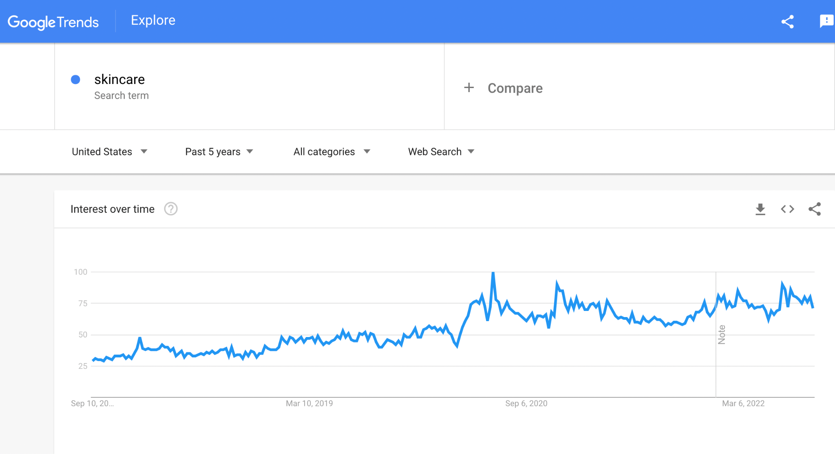

Appendix 1.1: Increasing SKINCARE Web Search

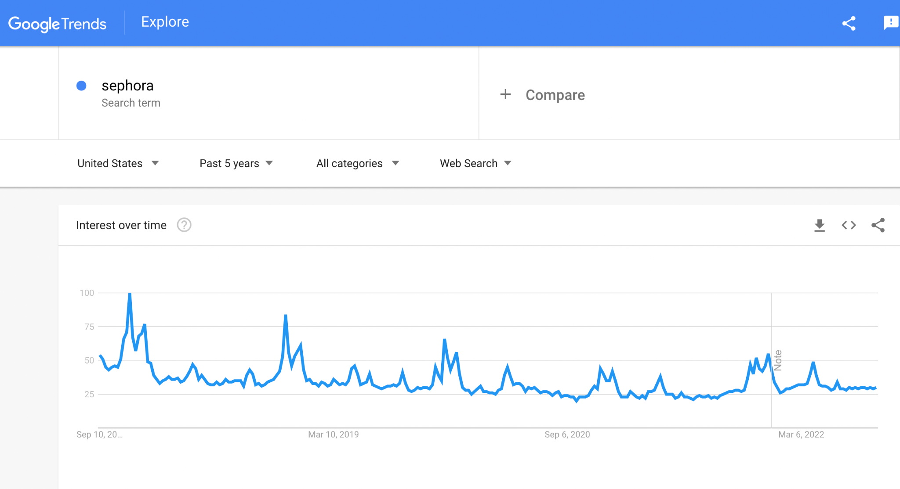

Appendix 1.2: Decreasing SEPHORA Web Search

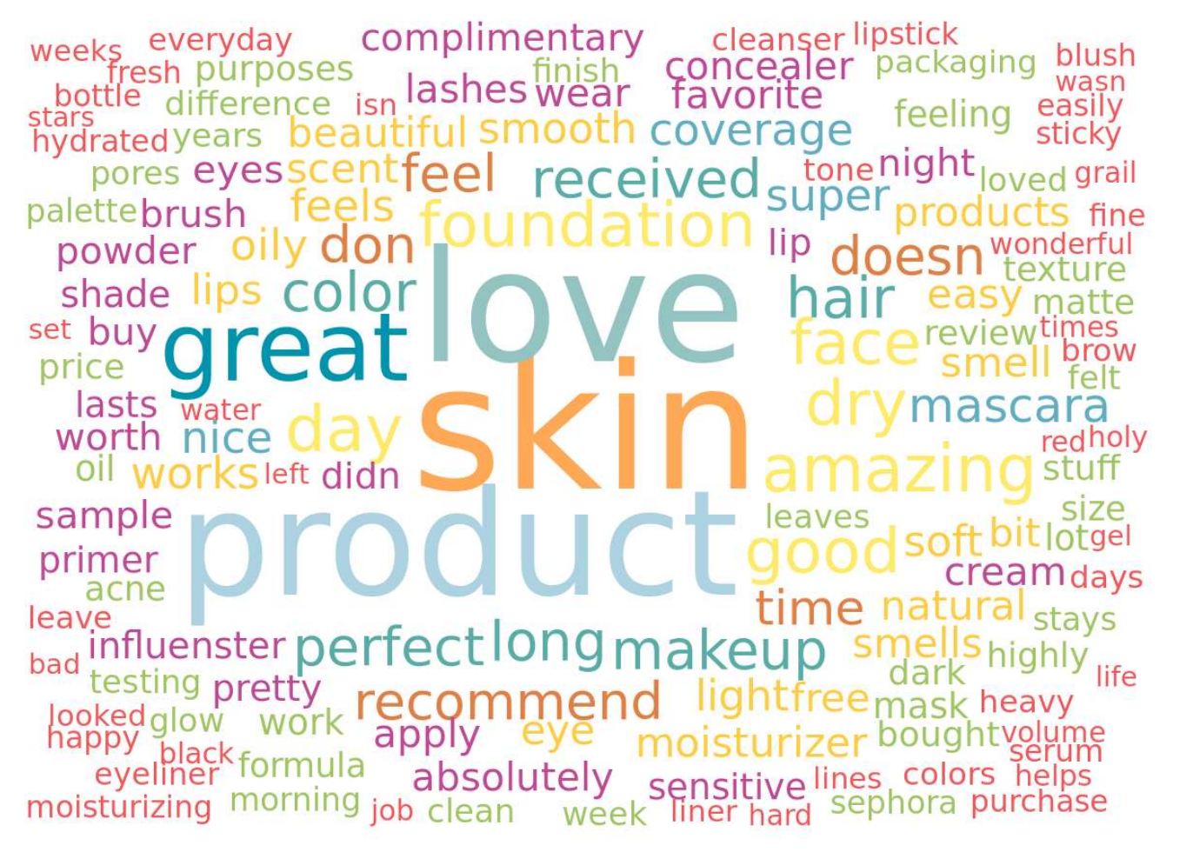

Appendix 2.1 Positive Reviews Word Cloud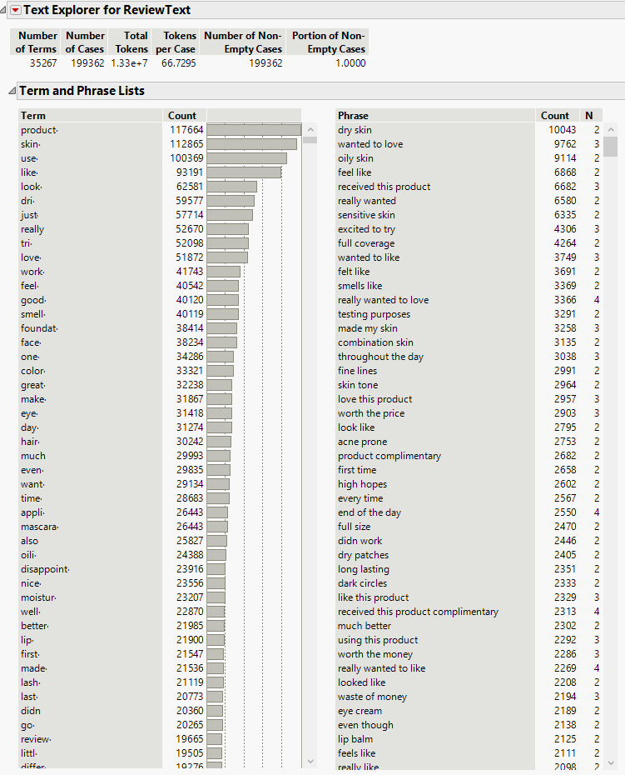

Appendix 2.2 Positive Reviews JMP Result

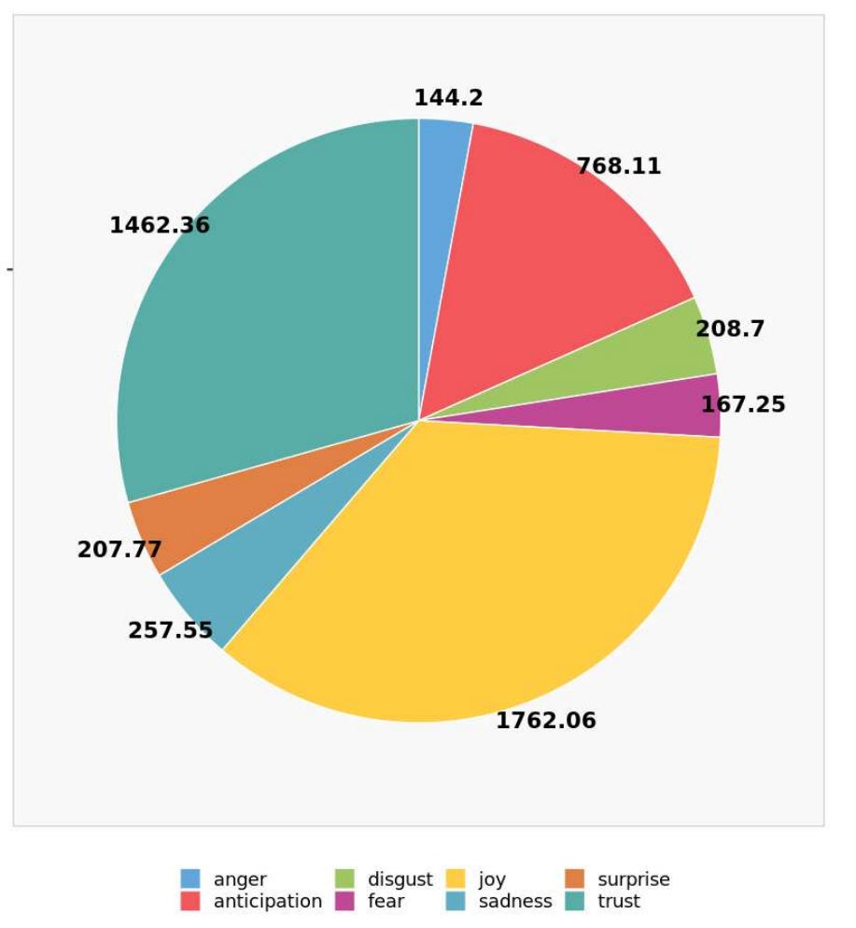

Appendix 2.3 Positive Reviews Emotion Analysis

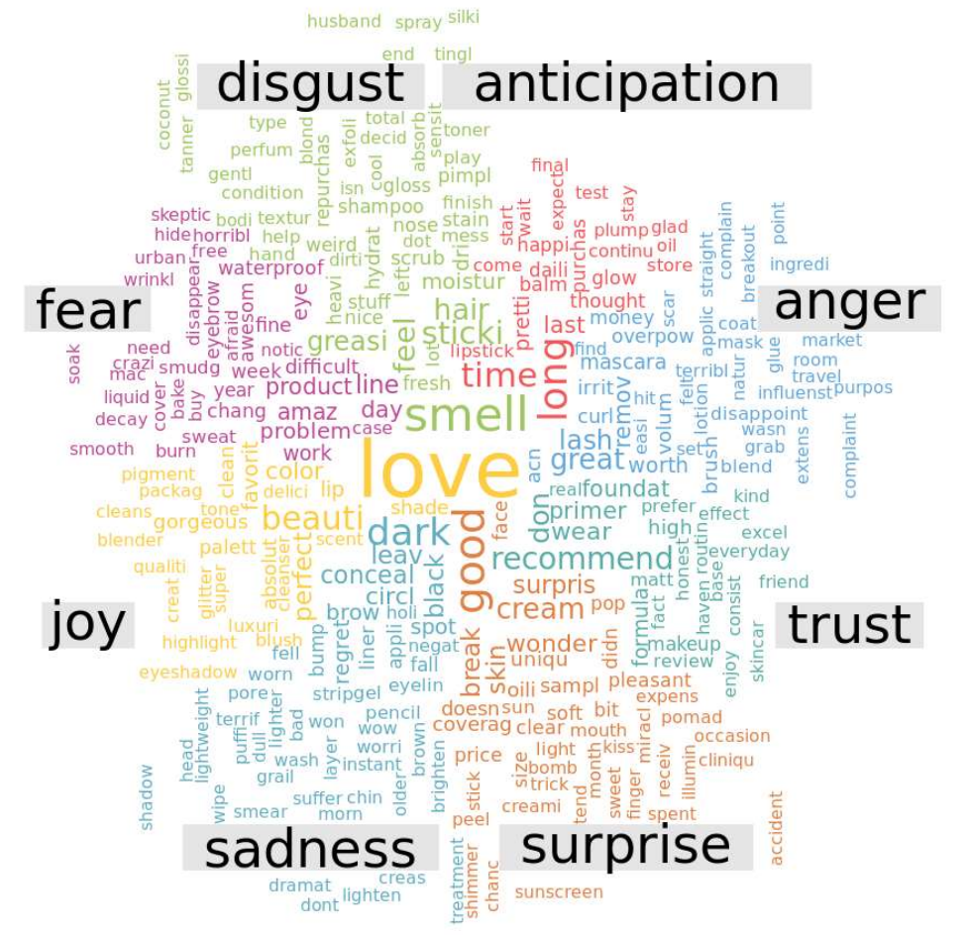

Appendix 2.4 Positive Reviews Emotion Analysis

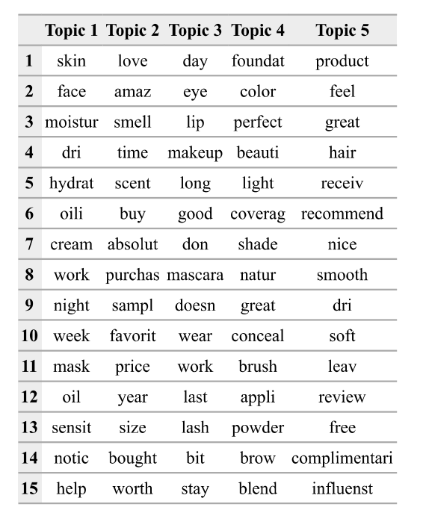

Appendix 2.5 Positive Reviews Topic Modeling

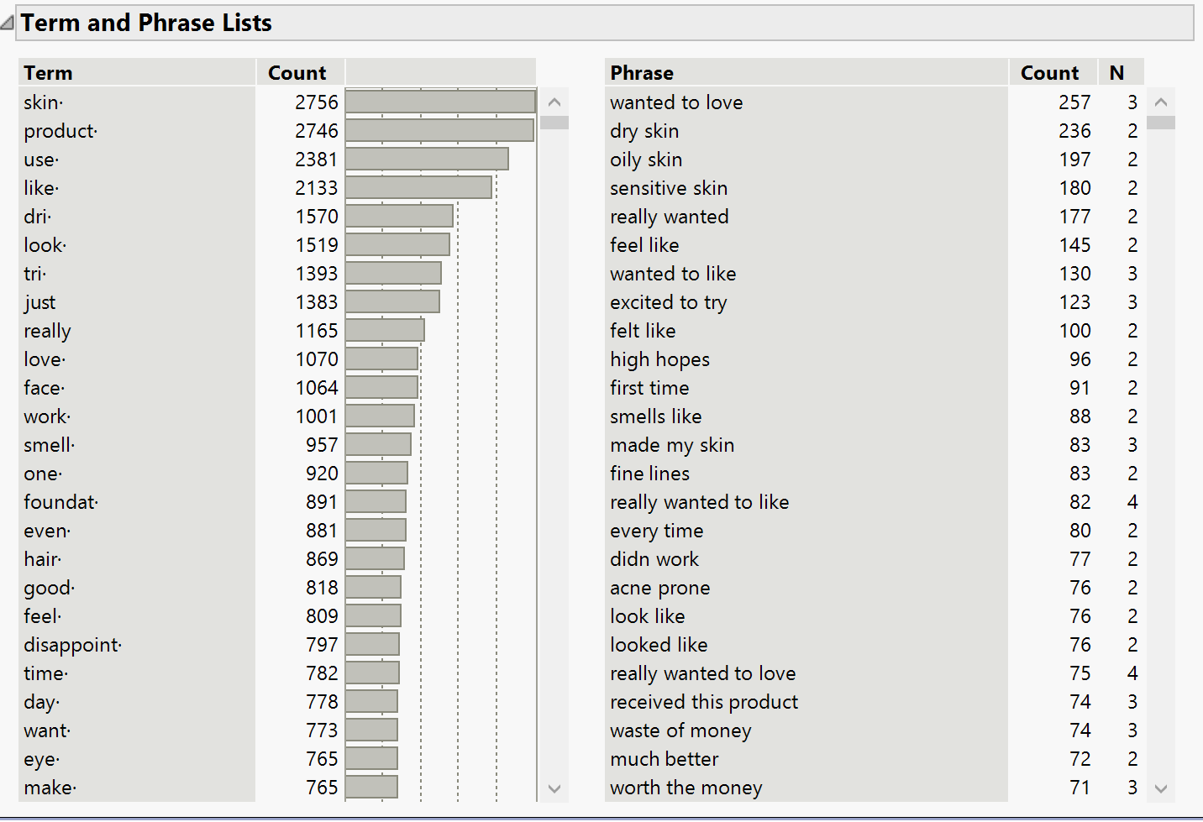

Appendix 2.6 Negative Reviews JMP Result

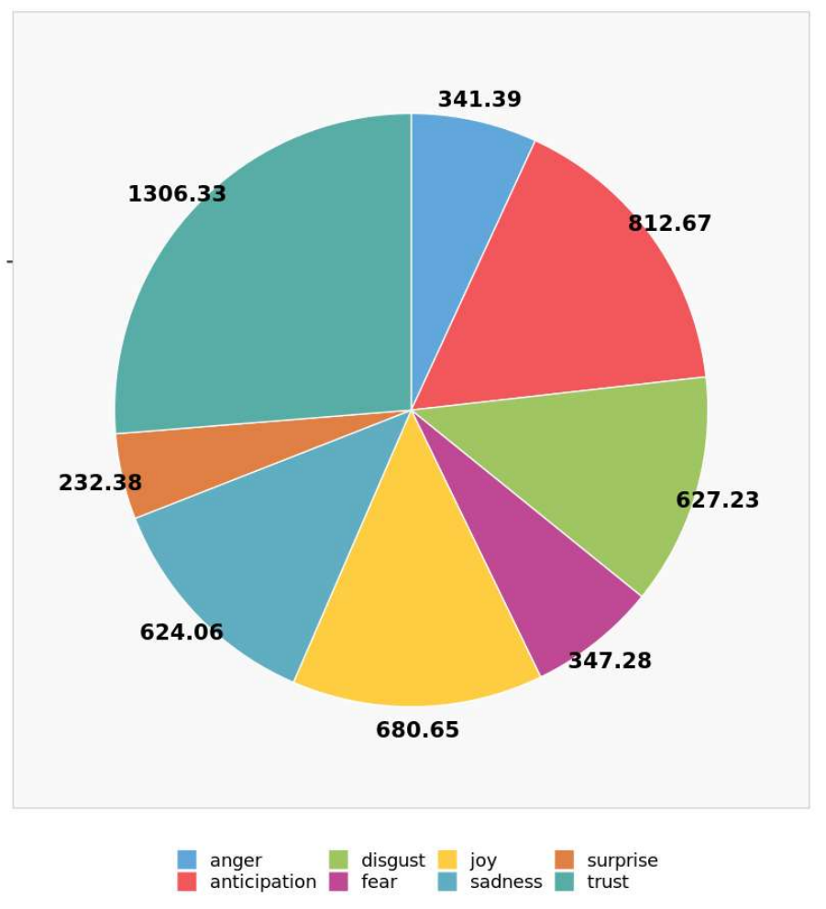

Appendix 2.7 Negative Reviews Emotion Analysis

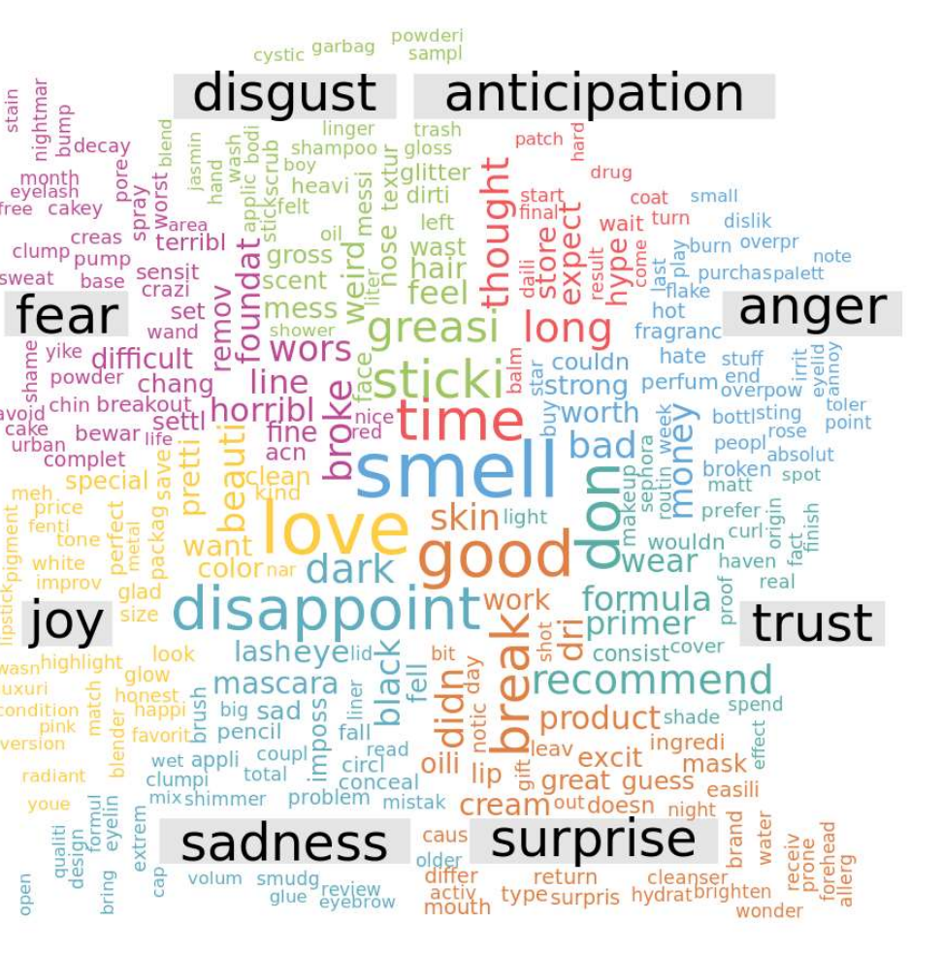

Appendix 2.8 Negative Reviews Emotion Analysis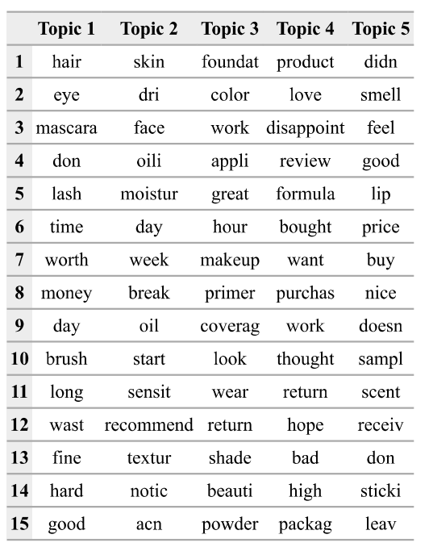

Appendix 2.9 Negative Reviews Topic Modeling



Appendix 2.10 Twitter Posts Word Cloud

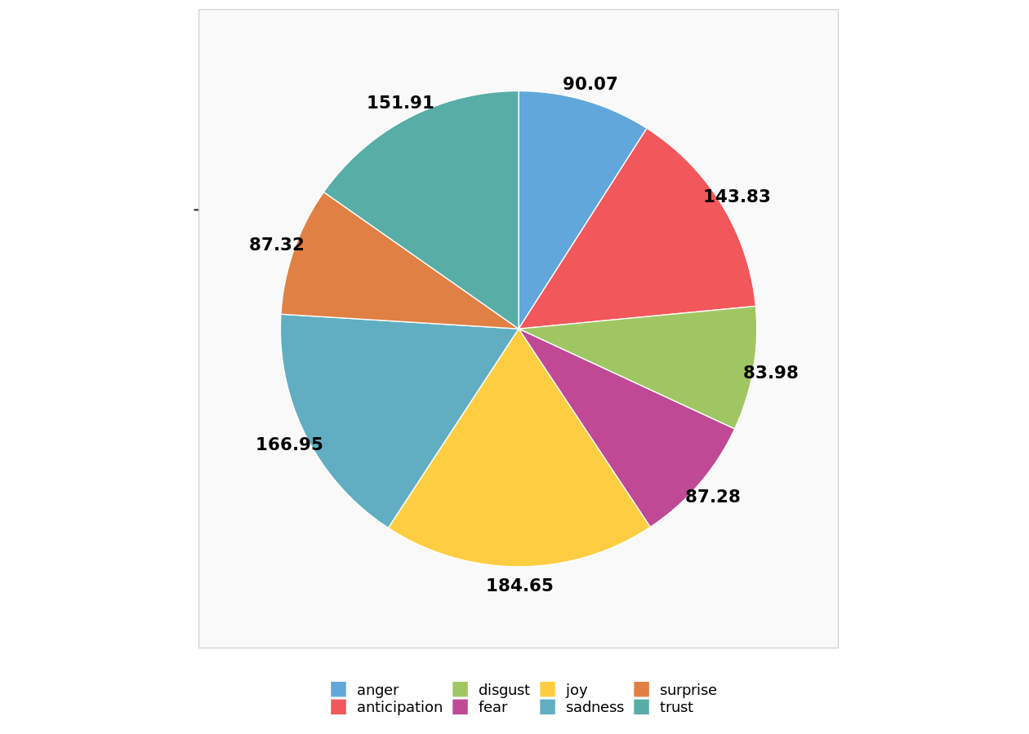

Appendix 2.11 Twitter Posts Emotion Analysis

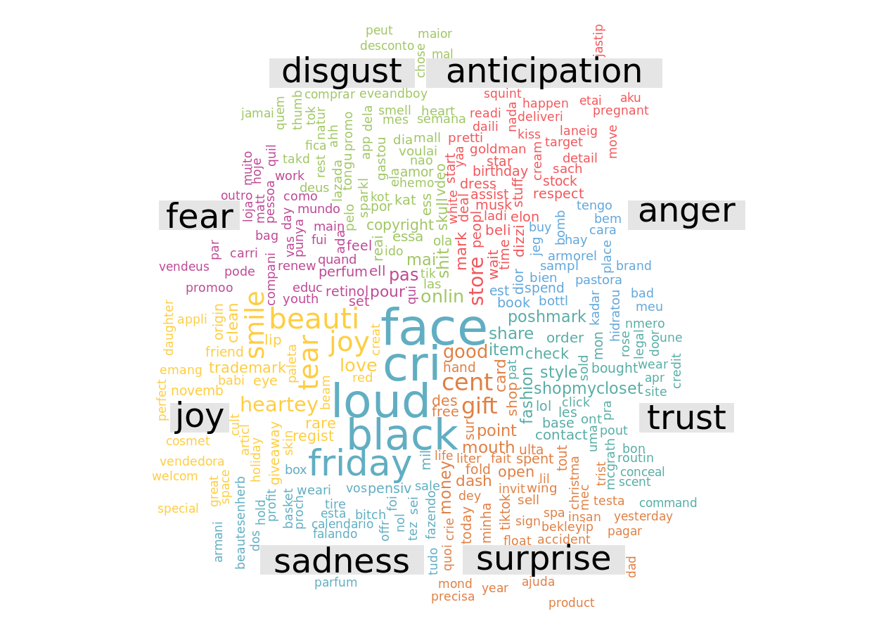

Appendix 2.12 Twitter Posts Emotion Analysis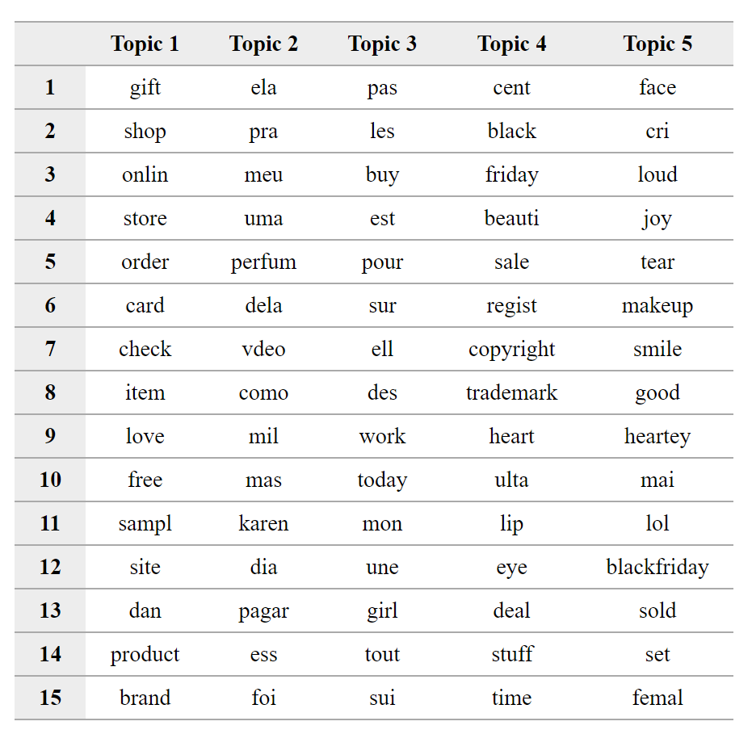

Appendix 2.13 Twitter Posts Topic Modeling

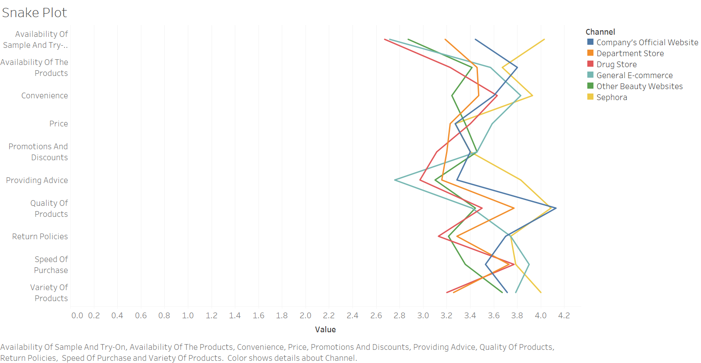

Appendix 3.1: Snake Plot



Appendix 3.2: Perceptual Map 1



Appendix 3.3: Perceptual Map 2



Appendix 3.4: Perceptual Map 3

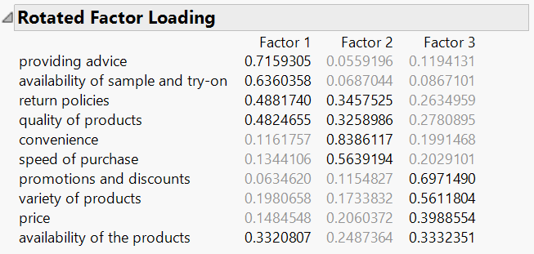

Appendix 3.5: Factor Analysis

|  |
| --- |
| **Segmentation Variables** |
| Return Policy |
| Providing advice |
| Sample and try-on |
| Availability of products |
| Quality of products |
| Price |
| Convenience |
| Speed of Purchase |
| Promotion and discounts |
| Variety of Products |

Appendix 3.6 Segmentation Variables

|  |  |
| --- | --- |
| **Descriptor Variables** | |
| Appearance | I pay a lot attention to appearance. (1: Strongly Disagree to 5: Strongly Agree) |
| Price-conscious | I am price conscious when I buy cosmetic products. (1: Strongly Disagree to 5: Strongly Agree) |
| Ingredients | I care about the ingredients of the products when I buy cosmetic products. (1: Strongly Disagree to 5: Strongly Agree) |
| Brands | I care about brands when I buy cosmetic products. (1: Strongly Disagree to 5: Strongly Agree) |
| Purchase convenience | I care about purchase convenience when I buy cosmetic products. (1: Strongly Disagree to 5: Strongly Agree) |
| Service | I care about the service when I buy cosmetic products. (1: Strongly Disagree to 5: Strongly Agree) |
| Same brand all the time. | I prefer buying cosmetic products from the same brand all the time. (1: Strongly Disagree to 5: Strongly Agree) |
| Self-trying than online reference | I prefer to try cosmetic products by myself rather than by reference online. (1: Strongly Disagree to 5: Strongly Agree) |
| Difficult to make choices | It is difficult for me to make a decision about which product to buy. (1: Strongly Disagree to 5: Strongly Agree) |
| Friends’ opinions | I prefer to get friends’ opinions before buying cosmetic products. (1: Strongly Disagree to 5: Strongly Agree) |
| Set and Combo | I prefer buying a cosmetic set rather than a single cosmetic product. (1: Strongly Disagree to 5: Strongly Agree) |
| Self-use | I usually buy cosmetic products for myself rather than for others. (1: Strongly Disagree to 5: Strongly Agree) |
| Rational | I think I am Rational (1) — Emotional (5) to cosmetic products. - Rational: Emotional |
| Youthful | I think I am Youthful (1) — Mature (5). - Youthful: Mature |
| Online | online or in-store? (1: Online 2: In-store) |
| Age | What is your age? (1: Below 18; 2:18-24; 3:25-30; 4:30-35; 5:36-40; 6:41-45; 7:46+) |
| Gender | what is your gender? (1: Male; 2: Female; 3: Non-binary/third gender 4: Prefer not to say) |
| Monthly Expense | What is your average monthly expense? (1: Below 1000; 2:1000-2000; 3:2001-3000; 4:3001-4000; 5:4000+) |
| Monthly Expense on Beauty | What is your monthly expense on skincare and makeup? (1: below 50; 2:51-150; 3:151-250; 4:251-350; 5:350+) |
| Education | What is your education level? (1: Diploma 2: Bachelor 3: Master 4: Ph.D. 5: Other) |
| Zipcode | What is the zip code of your residence? (Optional) |

Appendix 3.7 Descriptor Variables

|  |  |  |
| --- | --- | --- |
| **Clustering Comparison** | | |
|  | **Hierarchical** | **K-means** |
| **# of segments** | 3 | 4 |
| **Size for each segment** | Seg1:41% Seg2:43% Seg3:16% | Seg1:40% Seg2:9% Seg3:34% Seg4:17% |
| **SSE** | 2530 | 2200 |
| **Global hit rate** | 91% | 91% |
| **# of Statistically Significant Segmentation Variables** | 8 | 8 |
| **# of Statistically Significant Descriptor Variables** | 4 | 6 |
| **Interpretability** | Poor | Relatively good |
| **Targetability** | Bad | Good |

Appendix 3.8 Clustering Comparison

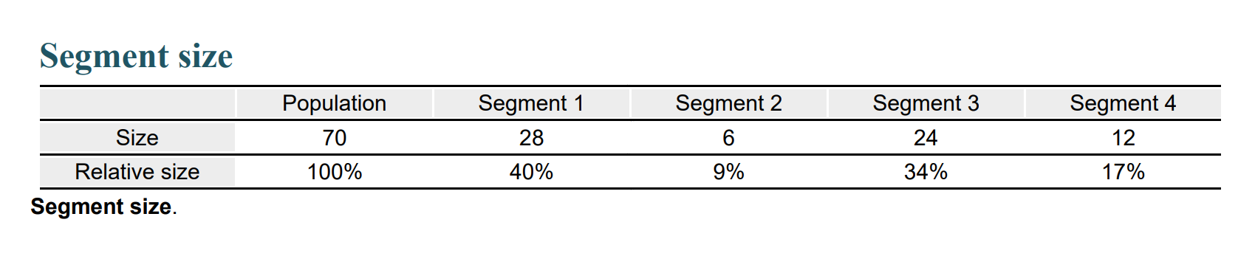

Appendix 3.9 Segment Size

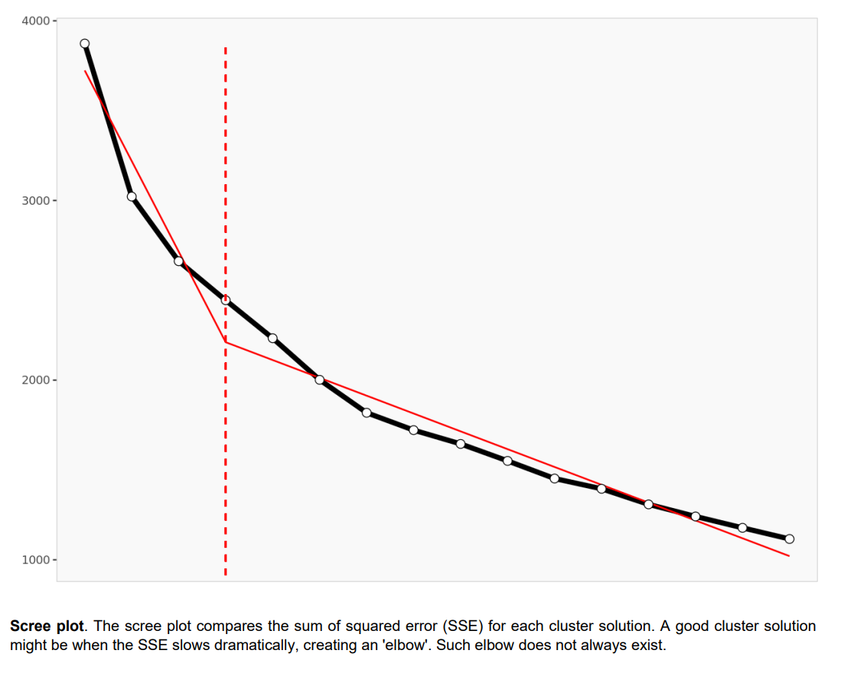

Appendix 3.10 Scree plot of segmentation

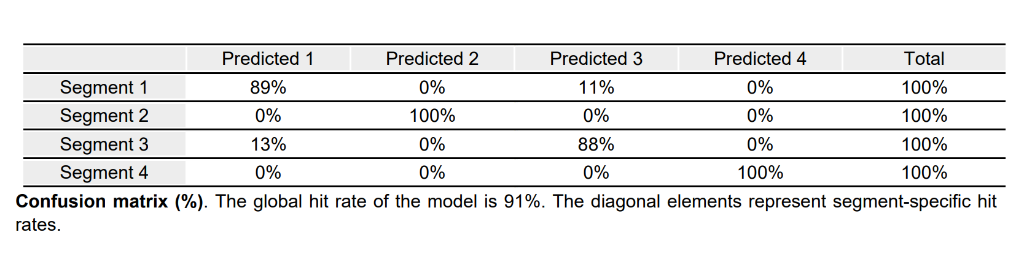

Appendix 3.11 Segments prediction



Appendix 3.12 Segment description

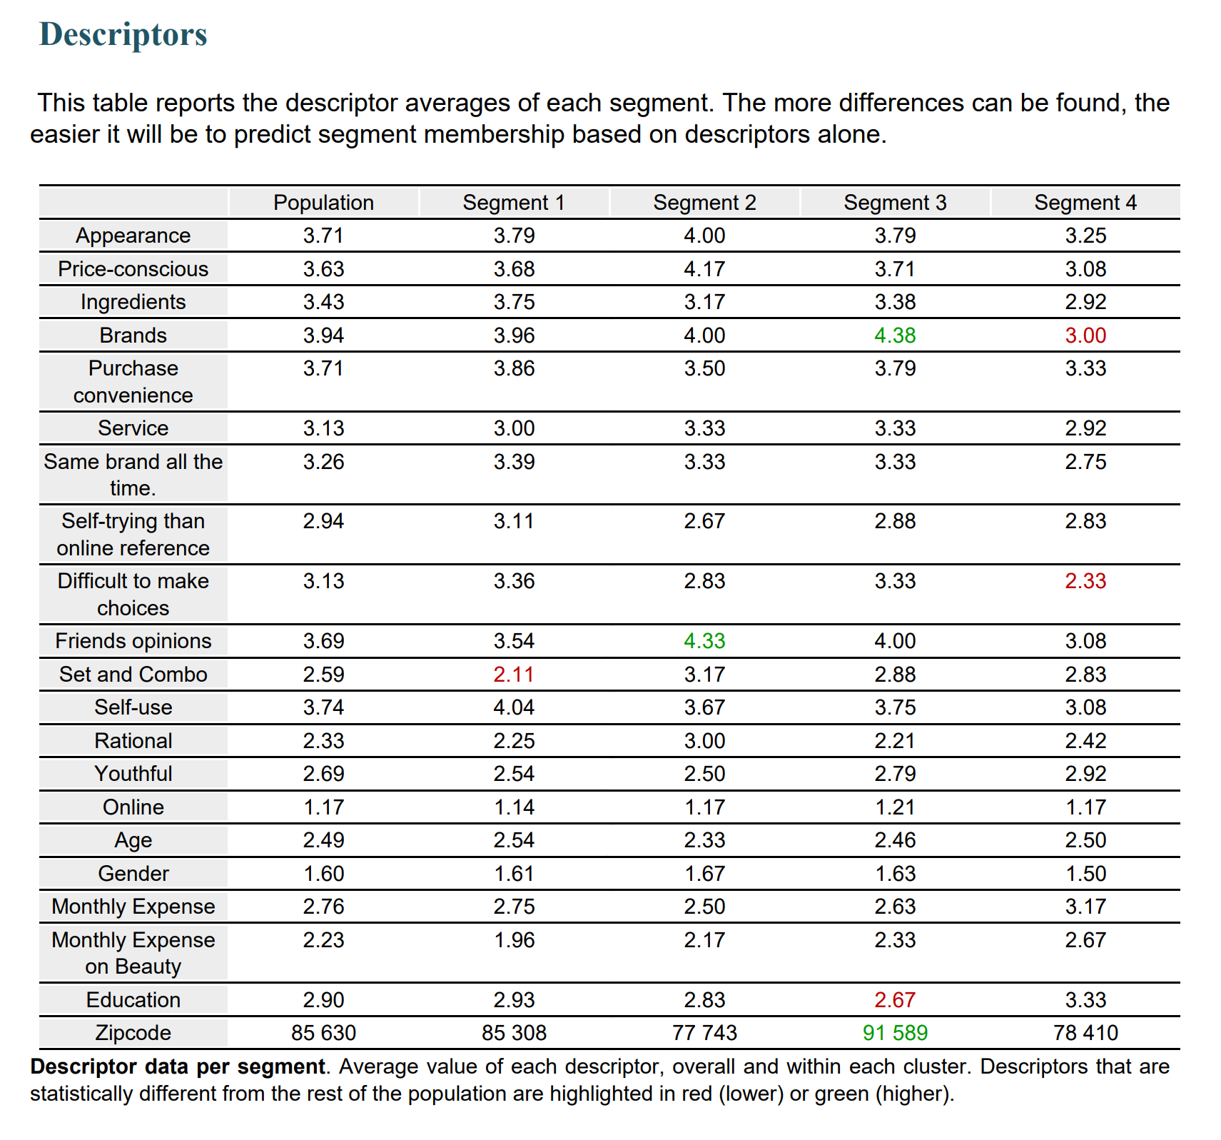

Appendix 3.14 Segmentation descriptors